Cod casa | NOILE PRETURI ALE SERVICIILOR DE RADIOLOGIE RADIODENT. SRL  DIN DATA DE 17.09.2026 | PRET/LEI
- | TRIMITEREA REZULTATELOR PE MAIL | GRATUIT
1 | PRINTAREA EXAMINARILOR RADIOLOGICE PE FILM MEDICAL | 10
2 | COPIE EXAMINARE – FILM / CD / DVD | 10
31 | MASURATORI CBCT (ZONE MICI - DIMENSIUNI SI DENSITATE)– DOAR LA CEREREA MEDICULUI! | 80
4 | RADIOGRAFIE RETROALVEOLARA | 50
6 | SCANOGRAFIE / RADIOGRAFIE ZONALA | 60
8 | OPT COPII (14 ANI ) / PENSIONARI (max. 1500 lei / pensie) / SOMERI | 60
12 | TELERADIOGRAFIE COPII (14 ANI ) | 60
10 | OPT ADULTI | 100
13 | TELERADIOGRAFIE ADULTI | 100
16 | CBCT ZONAL IMPLANT / DIAGNOSTIC | 190
27 | CBCT ZONAL - 2 ZONE SIMETRIC SUP/INF – STG/DR IMPLANT / DIAGNOSTIC / ENDO | 300
17 | CBCT SCOP ENDODONTIC / 1 – 2 DINTI ALATURATI | 190
15 | CBCT HEMIARCADA | 260
26 | CBCT HEMIARCADA - 2 ZONE SIMETRIC SUP / INF | 320
18 | CBCT MAXILAR SCOP DIAGNOSTIC / IMPLANT | 320
19 | CBCT MANDIBULA SCOP DIAGNOSTIC / IMPLANT | 320
20 | CBCT MAXILAR + MANDIBULA SCOP DIAGNOSTIC / IMPLANT | 420
21 | CBCT MAXILAR + SINUSURI MAXILARE | 340
22 | CBCT SINUSURI PARANAZALE (MAXILARE + FRONTALE + ETMOIDALE + SFENOIDALE) | 380
23 | CBCT ATM UNILATERAL | 190
24 | CBCT ATM BILATERAL | 360
29 | CBCT ATM BILATERAL 4 POZITII (GURA INCHISA + DESCHISA) | 600
30 | CBCT FULL SKULL(20 x 17cm)-CRANIU COMPLET–ORTODONTIE/TRAUMATOLOGIE) - BIMAX+ATM | 450
25 | CBCT FULL SKULL(20 x 17cm - VISCERO-CRANIU COMPLET – ORTODONTIE / TRAUMATOLOGIE) | 360 (<18ani)
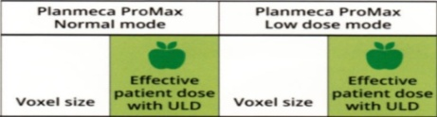
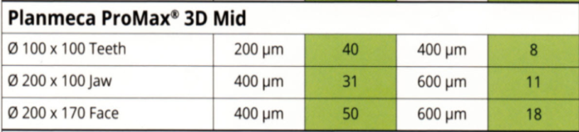
RADIOGRAFIILE 3D / CBCT / SUNT DISPONIBILE SI IN SISTEMUL Ultra Low Dose (ULD*) CEA MAI PERFORMANTA METODA DE CONTROL SI SCADERE A IRADIERII
Comparatie :
O RADIOGRAFIE PANORAMICA (OPT - ORTHOPANTOMOGRAFIE) ≈ 12-15 microSv

